PermaBurrow Mars Base Mission Proposal & Technical Report

Kush Jani

Virginia Aerospace Science and Technology Scholars

Abstract

Regarding the need for geological, atmospheric, and biological investigations on Mars before creating permanent bases of human habitation, this report proposes a mission to a small crater near the northern polar region of Mars under a mission name of PermaBurrow due to the extensive ice related focus of the manned base. This report proposes and designs an overview necessary for a prolonged mission to Mars utilizing a Phase III surface base with continuous occupation for 2932 days, or 96 months and 1 week. Describing a mission designed to research the MEPAG goals of Martian geology, biology, and climatology, this report examines the physical base needed to sustain a crew for such research. Such a base includes two laboratories and a greenhouse, as well as multiple rooms dedicated for the use of the 10-40 person crew and plants utilizing various chemical processes to derive valuable resources from the local environment through powering by nuclear power sources currently in development. Furthermore, the report examines the responsibilities of the crew due to the unique location selected and the environmental characteristics in order to divide responsibilities during seasonal shifts. Finally, the report examines some risks faced by astronauts in such an interplanetary expedition and mission while proposing potential solutions to such risks or ideas currently in development. With the proposed mission, the ability of humanity to establish a settlement on Mars will become more viable due to the greater level of knowledge and tested experience gained by the mission.

**Scope Summary Page: PermaBurrow**

* Need: Create a Phase III surface base on Mars to research the biology, geology, and climate of Mars’ past and present for increased human understanding in accordance with MEPAG requirements
* Goal: Understand past, current and future geological and atmospheric events on Mars through ice core chemical analysis alongside understanding biological factors and viability on Mars
* Objective: Create a Phase III surface base that includes mining operations, propellant production, long-range transport, and research into critical fields for future human settlement
* Mission: Land on Mars and sustain a crew for multiple years continuously and safely
* Operational Concept: Launch preliminary rovers and propellant producers, autonomously create foundations for base, launch crew, Hohmann transfer to Mars, setup rigid base temporarily, connect to 3D printer rooms using in-situ materials, inflate habitation spaces, setup labs, plants, and greenhouses, first crew group departure and planting of seeds, repeat crew arrival and departure processes with supply drops until final group departure, Hohmann transfer return to Earth
* Assumptions: Ability to create medical processes to resist radiation and have all necessary technologies and international coordination
* Constraints: Land the initial PermaBurrow crew on or before June 15th, 2040, and launch for return on or before June 25th, 2048; maintain Phase III base with 10-40 crew
* Authority and Responsibility: PermaBurrow is to be headed by NASA interagency cooperation between NOAA Ice Core facility and other international space agencies.

**PermaBurrow Mars Base Mission Proposal & Technical Report**

Pushing boundaries and exploring new frontiers are inherent traits in humanity as a whole, reaching back from the prehistoric era and into the modern age to power advances. The unquestionable pursuit of knowledge pushed scientists and astronauts through the space race to unlock a new frontier hosting an incomprehensible number of resources and opportunities for future generations. Yet, while the moon landings were an enormous accomplishment, the exploration of the new frontier has only just begun and necessitates planning on further goals to commence. With Mars being the closest planet to Earth in distance and habitability, missions to Mars must revolve around the eventual settlement and colonization of the uniquely suited extraterrestrial body to support future pursuits. However, such an ultimate goal requires a significant amount of research and development, with knowledge and ability being accrued through multiple successive missions in order to tackle both the environmental and logistical challenges inherent to Mars and Mars missions. Any such mission also faces considerable challenges and requires thorough planning to meet the needs of researchers on Earth set by the Mars Exploration Program Analysis Group (MEPAG), which have dictated exploration into atmospheric, geological, and biological conditions of Mars (Mars Science Goals, n.d.). Concentrated on advancing towards a permanent base on Mars, the proposed mission shall focus on the creation of a Phase III base with the necessary scope needed to sustain its crew and carry out discoveries in the fields of biology, geology, and climatology while allowing for expanded settlement capabilities overall, as set forth by the MEPAG goals, in order to best prepare mankind for a future on Mars.

**Mission/Surface Base Name & Mission Constraints**

The proposed Martian base will be of tremendous importance to future generations of Martian endeavors as the guidelines made for the proposed mission dictate the discoveries that will serve to fill gaps in current understanding that prevent permanent habitation on Mars. As a Phase III base, the proposed surface base will act as a simulation of the Phase IV and V bases that shall become the starting point for Mars colonization and settlements and thus will play a large role in the viability of future bases. As a result, the need for the proposed base to be centered on research into the fields of biology, geology, and climatology on Mars as set by MEPAG and scientists worldwide is as critical as testing the ability of a semi-permanent base on Mars. Aside from research constraints, the mission overall faces pressure to accelerate development of human capabilities in space as the potential for resource availability in space would allow for exponentially improved lives for humanity. Therefore, the proposed mission must be launched prior to 2040 and completed before 2050 to suitably allow for greater knowledge while paving the way for a potential permanent colony before the end of the 21st century. Finally, the base also shall be constrained by its status as a Phase III base, which allows for a crew size between 10 and 40 to accomplish the research objectives into the fields of biology, geology, and climatology along with the settlement goals. Corresponding to these main areas of focus, the proposed mission will be referred to as the PermaBurrow mission due to the name’s alignment with the primary characteristics of the base. Specifically, the prefix “perma”, meaning fixed, used alongside the word burrow, which can mean dwelling, refers to the Phase III characteristic of the base as being a permanently occupied dwelling for the Mars astronauts. Additionally, the mission will revolve around ice coring and mining operations near the northern Martian pole since water ice is solely present in Martian summers, allowing for the collection of ice cores that provide geological, biological, and atmospheric signals in a preserved chronological format due to dust deposited by Martian dust storms over time (Seasonal Changes, n.d.). This environmental characteristic, utilized in the previously proposed PolarCorer robotic mission, serves as an additional meaning behind the name of this proposed PermaBurrow mission as burrowing, coring, and mining Martian permafrost and ice will be integral parts of the research side of the mission and shall dictate certain characteristics of the mission. While any missions to Mars are constrained by the challenges of Mars’ harsh environment, research requirements, and mission characteristics, the PermaBurrow mission shall enable humanity to take steps forward into the frontier of space and establish a permanently occupied surface base on Mars.

**Outpost Location**

With consideration of the constraints and requirements of the mission and surface base, the location of the base plays a critical role in providing an appropriate environment for the crew to meet mission objectives in research and remain as safe as possible. In order to meet mission objectives for research and settlement, such as those set by MEPAG, water ice is essential. As aforementioned, ice cores have considerable benefits for the research purposes of the mission by offering unique insights into the geology and climate of Mars’ past alongside potentially cryogenically preserving biological life or its signals. Studies performed by NASA have determined key factors in selecting sites for ice coring on Earth, which have the potential to be used on Mars, such as locating regions less susceptible to repeated thawing and melting due to the diffusion of chemicals and signals (First Ice Cores from Mars, 2021). However, Mars contains and atmospheric pressure far lower than that on Earth and therefore is unable to sustain liquid water as ice immediately sublimates to water vapor, which beneficially prevents diffusion in the ice layers and ensures that collected samples during the mission will be relatively well preserved. Mars ice collection is also different in many ways from collection on Earth due to the unique characteristics of Mars. Specifically, due to the extremely low temperatures found on Mars, carbon dioxide freezes and results in dry ice deposits being found across Mars’ poles until summer seasonal changes from Mars’ Earth-like tilt makes the northern pole warm enough to sublimate the ice (Seasonal Changes, n.d.). With this seasonal change in temperature, water ice will be the only form of ice available during the summer season, allowing for efficiency in astronaut research as focus on water ice will be far more important due to its permanent nature. Since the northern polar region has been documented for years in having only water ice during the summer months of Mars, the location of the base must be around a location with water ice near the norther pole. With these criteria in consideration, the prime location for the PermaBurrow Mars surface base will be in a small crater located at 70.5 degrees North and 103 degrees East in the Vastitas Borealis due to the year-round presence of water ice in a 200-meter 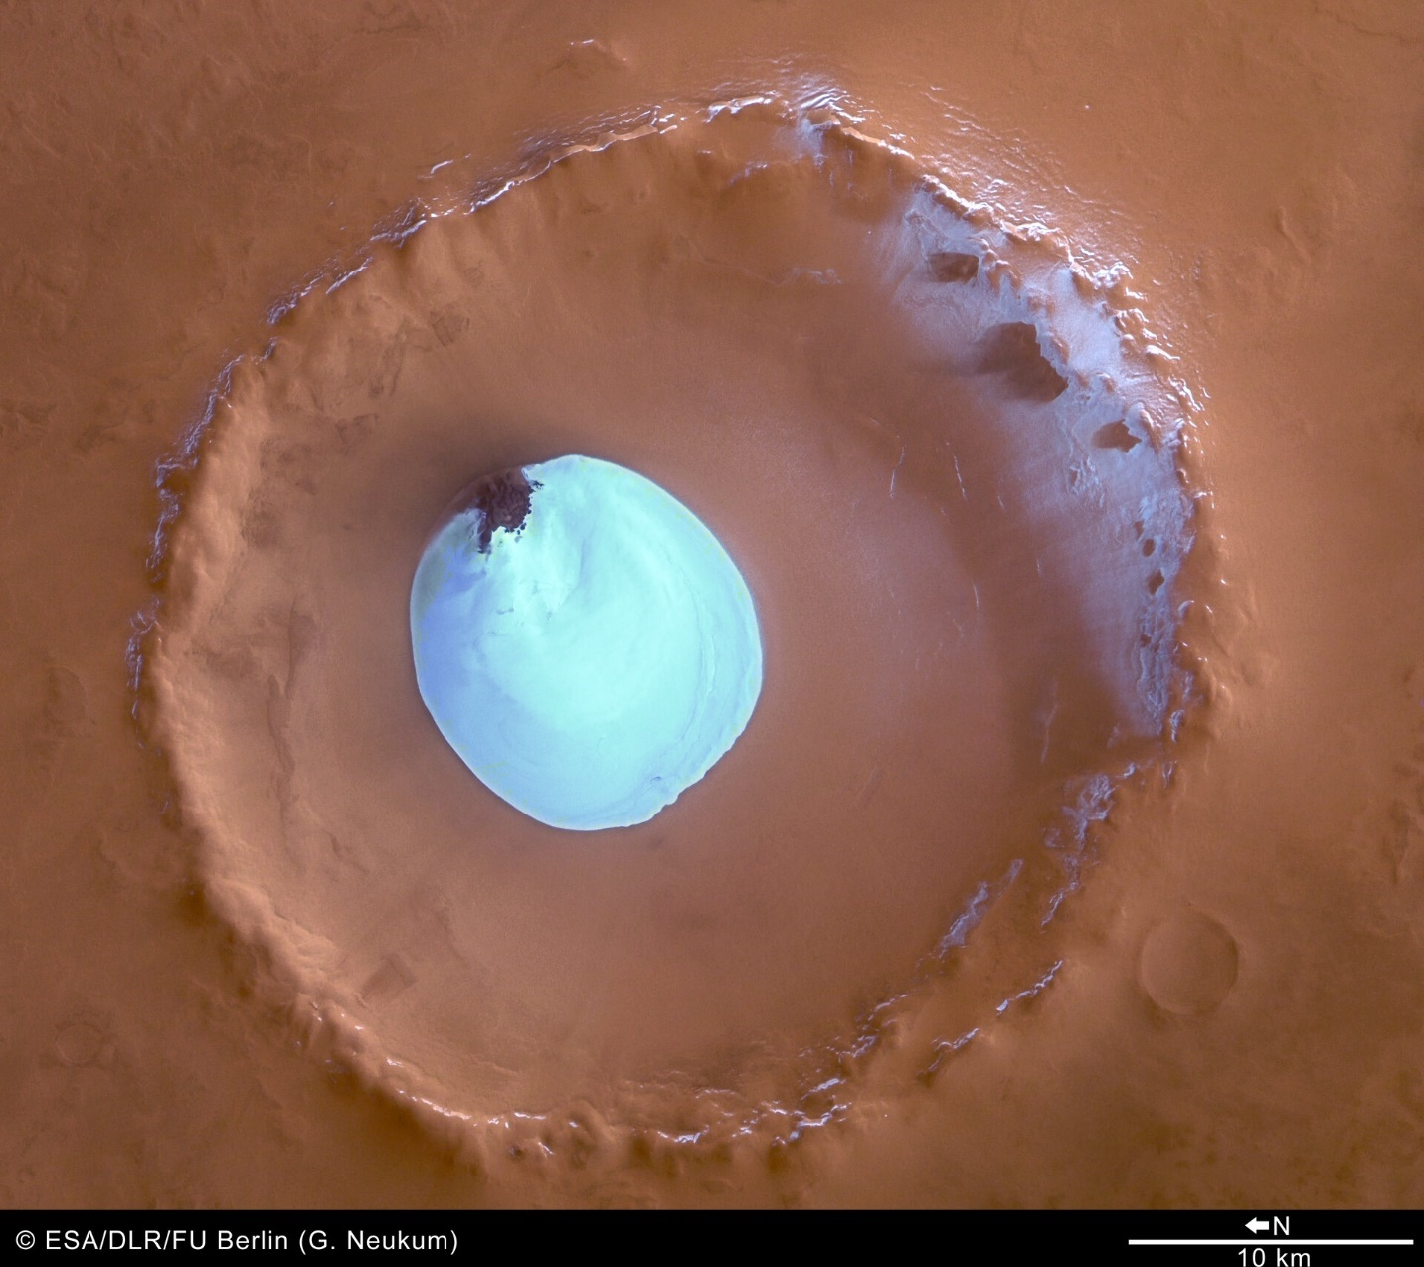patch inside the crater (Water Ice in Crater, 2005). The site (see Figure 1) provides an ideal opportunity for the Mars mission as the abundance of water ice is coupled with positioning inside of the large waste region on Mars known as Vastitas Borealis, which in some theories is the result of a water ocean and would thus have the potential for sedimentary microbial life (Miller, 2022). This site is located inside of a thirty-five kilometer wide crater that has a maximum depth of two kilometers with the warmest region likely being the north-western side due to the absence of water ice on the rim (Water Ice in Crater, 2005). The Mars surface base itself shall be positioned in the north-west portion of the ice patch which reveals the dunes and structures beneath the ice, allowing for potential geological research inside nooks and crevasses and natural landscape shielding for the base. Furthermore, this location will allow for quick access to the more elevated portions of the dunes as recommended by NASA ice coring guidelines (First Ice Cores from Mars, 2021). Within this crater, the mission will be best able to complete the objectives in research and settlement as the access to an abundance of water shall provide ample opportunities for resource development and sample collection.

Figure 1

**Mission Requirements and System Requirements**

The PermaBurrow mission to Mars will have separate research objectives and systems objectives in order to best meet the needs set forth by the MEPAG goal. However, due to the interdisciplinary nature of science and the need for efficient and effective research, some requirements throughout the mission will overlap. The primary objective of the PermaBurrow mission on the systems side will be the general completion of a habitable base that is able to be sustained for the duration of the mission, which thus requires the maintenance of crew support systems and the physical structure and components of the base. These structural components of the base shall be built upon the mining and burrowing aspect of the mission as, following the deployment of the initial rigid base capsule, astronauts will utilize a lava casting method developed in cooperation with NASA to layer molten sand and create 3D printed rooms (Imhof, 2016). Inside of these rooms, the crew members of the mission will be able to begin inflating semi-rigid prefabricated spaces designed to modularly construct the base efficiently while using the least amount of weight. Since the weight of launched items directly corresponds to the cost of a mission, minimizing the weight requirements will be a recurring thread in the mission. With the completion of the inflation of prefab spaces inside of the protective printed rooms, astronauts will be able to begin working on setting up spaces such as the two laboratories, with a geological and climate lab in one space and a biological lab in the second space, and the greenhouse of the mission. These three components of the base serve as the primary locations for research related to meeting the mission objectives of determining the biological, geological, and atmospheric conditions of Mars. The greenhouse will be utilized to discover traits about growing plants for the furthering of knowledge on the viability of self-sufficient agriculture on Mars. By growing plants on Mars, astronauts will be able to take advantage of the exclusive conditions of Mars, such as the limited gravity and radiation, in order to answer potential questions about mankind’s ability to settle Mars. Aside from these three spaces will be the spaces necessary for the crew, including the bunks and gym areas necessary for proper crew health to be maintained. A dining hall will also be part of the base design in order to promote crew camaraderie and prevent isolative feelings during the course of the mission. Also necessary will be the medical space, which will serve as space for the medical professionals of the crew to monitor the health of other crew members and also provide for any medical emergencies that arise. Finally, the base design will include the various plants and mining facilities located near the core living and working area of the base. Utilizing various methods such as the Sabatier process and MOXIE’s technology, these plants will be able to produce oxygen, water, and methane for fuel and propellant production on the surface of Mars using primarily the resources found in the air and soil (Sabatier System, 2018). Plants will also be used to sustain the crew as mined water ice shall be heated in a pressurized chamber to create water, which can then go through the process of electrolysis to generate hydrogen gas and oxygen or be stored for the consumption of the crew as water. Once more, the utilization of in-situ resources shall allow for lower costs associated with the mission and also serve to allow for the crew to remain safe and healthy. These plants will, however, require an abundance of power to use and the power generation of the base will thus be mission critical in order to keep life support systems fully functioning. While solar power will be utilized for providing power for the rovers and vehicles of the base, the primary means of powering such a sizable base could not rely on solar power since associated requirements of batteries would create unreasonable weight requirements for the mission launch. Nuclear power provides an exceptional opportunity as the density of power provided in comparison with the weight is unrivaled, allowing for lower costs to be achieved, and the technology has been proven through NASA research and experiments as an optimal method for powering Martian bases (Hall, 2017). Serving to support the crew and systems requirements, the successful creation of the proposed base shall be an important milestone in the operational concept of the mission. However, the systems requirement are only half of the operational concepts as the mission requirements needed for the completion of the research objectives serve as an equally important objective necessary for the successful completion of the mission. Mission objectives for the research shall focus on meeting the goals set by the MEPAG science investigation priorities committee on the topics of Martian geology, climatology, and biology. For geological research, a priority should be placed on documenting the geological record of Mars but also on investigating the various processes that modified said geological record. For example, by investigating the ice cores during the mission, finding diffusion of layers or misaligned layers could signal potential geologic events. Meeting this objective during the mission timeline will require dust sample analysis using chemical analyzers and microscopes. Climatology during the mission will also be able to utilize water ice core samples as the chemicals present in the ice will provide a preserved insight into the atmospheric makeup for Mars through various periods of time. Furthermore, sensors present on the base will also be used to monitor the local makeup of the atmosphere and other atmospheric traits in order to both record data for atmospheric research and allow for crew safety by predicting weather patterns. Finally, biological research on Mars will be done through two primary means, including the search for evidence of extant life on Mars and the observation and experimentation of various plants grown in the greenhouse of the base. Examining the makeup of water ice and potential presence of cryogenically frozen microbes, along with the presence of fossils or life signatures in geological samples, research in the field of biology will focus more on finding signs of life while the greenhouse experiment will focus on examining life. The proposed operational concepts set the scope of the mission and are pivotal in defining the success of the PermaBurrow mission as meeting the system and mission requirements allows for the smooth completion of important mission events.

**Mission Timeline**

The proposed PermaBurrow mission will need to begin as rapidly as possible to provide humanity with as much knowledge as necessary for a future permanent settlement. As previously mentioned, the need for understanding Mars dictates that the mission must launch crew prior to 2040 and return crew prior to 2050. Since initiating the base and settling the crew into the new base will take time, the crew’s arrival must be set for the beginning of the Martian summer, or a summer solstice. In order to provide the most amount of time before the deadline of 2050, the crew shall therefore arrive on Mars by the summer solstice on June 15th in 2040 (Gangale, n.d.). With a 30-day buffer period for maneuvering when both leaving Earth and arriving at Mars, the crew shall use a Hohmann transfer period of 259 days to launch from Earth on August 31st of 2039 in order to meet the June 15th arrival day (James, 2020). Yet, before the crew begins their initial launch, plants for the creation of fuel using the Sabatier process will be sent such that ample time is provided for reserve fuels to be ready by crew arrival. With an arrival date of one year prior to the June 15th crew arrival, the plants and rovers necessary to construct the plants and other preliminary measures shall be launched on August 31st of 2038, 654 days before the crew arrival, to have a 30 day buffer, 259 day Hohmann transfer, and year-long stay on Mars during which critical events like the initialization of the rovers and the plants will take place. With the crew and the tools needed by the crew available on the June 15th date, the first year will be allocated for the construction and completion of the base, which will be finalized with the planting of the first crops on June 15th of 2041. During this first year, 10 additional crew members will arrive every 3 months such that the departure of the initial 10 crew occurs on June 15th of 2021. This cycle of crew replacement will continue in order to maintain crew times on Mars at a maximum of one year. During the second year, the first crop harvest will also take place, which will allow for research activities in all three fields to wholly take place. May 3rd of 2042 will also mark the return of summer as a full Martian year will have passed since the first crew’s arrival. This cycle will continue until the beginning of the summer on Mars in 2047, which will occur on December 24th, from which astronauts will have until June 25th of 2048 to begin winding down base operations until, on June 25th of 2048, only 10 crew members remain. This final departing crew will launch at the beginning of fall on Mars, which is June 25th of 2048, and take a Hohmann transfer of 259 days with a 30-day buffer to return to Earth on April 10th of 2049 (Gangale, n.d.). During the final summer of the PermaBurrow mission, astronauts will focus on winding down operations and making sure that safety is maintained through the deactivation of the nuclear energy producers and the gathering of all necessary samples to be taken on the final departure. With the mission spanning between June 15th of 2040 and June 25th of 2048, the total time spent on Mars occupying the base will be 2,932 days. During this time, hundreds of crew members will have contributed to accomplishing the necessary activities of the PermaBurrow mission and improving the overall understanding humanity has for Mars, readying humanity for its future home.

**Crew Responsibilities and Functions**

Within the requirements of the mission, the crew plays a fundamental role and characterizes much of the mission by simultaneously allowing for more general roles in the operational concepts due to human ingenuity and adaptability but also constraining and confining the mission due to fragility of humans and the various needs. As a result, the crew selected for any manned mission must always have the qualifications and abilities that outweigh the associated costs of manned exploration by capitalizing on the adaptive nature of humans. Furthermore, by having more overlap between the crew, requirements of crew size are mitigated while camaraderie between members is increased as topics in common are inherently present. Since each crew arrives in groups of ten, certain responsibilities should be shared between arriving group members. For example, each group of ten must contain two medically certified professionals who are able to meet the needs of the group during the interplanetary travel and during the time on the surface. Therefore, when all forty crew are at the base, at least eight medical professionals will be available in the event of an emergency, which ensures that a medical professional will be available inside the base at all times. Each group of ten must also have one engineer, in order to prevent any catastrophic mechanical failures during interplanetary travel, and include a commanding leader to decide for the group of ten. Consequently, when all of the crew are at the base, a committee of four leaders will be available to make large decisions and manage specifics tasks. Three leaders will be in charge of the research fields of biology, geology, and climatology while another leader will remain in charge of the systems requirements and logistics of the base. During the summer portion of the Martian year, research will revolve around the collection of samples by astronauts from both the patch of water ice at the caps and the dunes surrounding the crater. Astronauts collecting samples will be versed in their field of research and collaborate with agencies from Earth in order to best select specimens for research. Astronauts will also be best able to complete longer expeditions past the area near the base on rover, crossing beyond the crater rim in convey missions intending to explore and locate more varied sites. By accessing sites that are further from both the base and the crater itself, astronauts will be able to mitigate selection bias in collected samples and also find different geological forms for researchers to look into. During the colder winter portions of the Martian year, astronauts will focus on analyzing their samples and working on the greenhouse. The crew will also be able to assist with construction of the base and mining for water during all times of the year and, during the end of the mission, those crew members who are not departing will also play a large role in ensuring the safety of departure for the crew. The initial crew for the first year of the mission will consist wholly of American crew members from NASA. However, as missions continue, more crew members from other nations will be allowed to compete for positions such that at least ten crew members are from international space agencies beyond NASA. These crew members will be generally evenly split in gender, with half of the crew being male and the other half being female. With such a diverse crew accomplishing such a variety of tasks, the gaps in human knowledge on Mars will rapidly be replaced with knowledge readying mankind for permanent life on Mars.

**Risks/Dangers**

Since the Apollo moon landings, the next step in human exploration of the frontier of space has always been Mars. While Mars’ habitability is far greater than other planets in the solar system, the Martian environment remains far more hostile than the most dangerous locations on Earth. One of the most easily identifiable dangers of any mission to Mars is the astronomically vast distance separating it from Earth. Unlike astronauts during the moon landings or aboard the International Space Station, the time it takes to travel to Mars is magnitudes greater than those elsewhere as years rather than months separate any crew from receiving assistance during emergencies. Furthermore, psychological issues are also created due to the extraordinary distances as even light takes minutes to reach Mars, resulting in live communication being impossible and full human contact being solely between crew members for the duration of the mission. However, these issues will be mitigated during the PermaBurrow mission through the use of qualified crew members who will be able to provide therapy and guidance for the crew and be well trained and organized for any emergencies (Mars, 2018). Other issues faced by the crew remain more challenging and pervasive, as radiation and microgravity will act invisibly to wreak havoc on the health of crew unless otherwise prevented. The journey into interplanetary space and onto Mars will result in abandoning the magnetic field that protects the Earth from hazardous radiation, which attacks the DNA of humans to results in development of cancer and other diseases (Magnetic Shield System, n.d.). Mitigating this radiation will be crucial as, even with the limited year-long stay of the astronauts, the combined trip time will result in years of exposure. Utilizing the Martian soil for the casing around the base will assist astronauts by blocking some of the radiation, while medical preventatives developed prior to the mission for radiation resistance could also be utilized. The microgravity of space and limited gravity of Mars will also cause issues, such as bone damage, due to the lack of support provided by a weakened musculoskeletal system. By utilizing exercises and weight training tools such as those used on the International Space Station, astronauts could prevent such issues from developing (Mars, 2018). While the risks of isolation, radiation, and limited gravity will be present for astronauts in any interplanetary missions, careful mitigation of these risks through procedures and medical assistance will enable any such missions to be successful in meeting objectives while maintaining crew wellbeing.

Humanity has an inherent need to explore and understand the world. From the beginning of astronomy to the current beginnings of exploring the frontier of space, Mars has continued to be a planetary neighbor destined to capture human imaginations of new worlds. Even with the moon landings, humanity has not yet set foot on another planet but, with the proposed mission, will get the ability to stay. By investigating the science behind the environment of Mars, a new generation of explorers will be better able to take advantage of the boundless resources provided in space. The PermaBurrow mission will become a starting point for not just the colonization of Mars, but the settlement of the entire solar system. Digging deeper into the world has provided mankind with so many improvements, and doing so on Mars shall prove to be no different as learning more to better the world has been and will continue to be the driving force behind human exploration and endeavors.

References:

*First Ice Cores from Mars. NASA*. (2021, February). Retrieved April 06, 2023, from https://www.nasa.gov/sites/default/files/atoms/files/mars_ice_core_working_group_report_final_feb2021.pdf

Gangale, T. (n.d.). Retrieved April 9, 2023, from https://www.nasa.gov/directorates/spacetech/kilopower/

Hall, L. (2017, December 12). *Kilopower*. NASA. Retrieved April 9, 2023, from https://www.nasa.gov/directorates/spacetech/kilopower/

Imhof, B.(2016, July 17). *An ISRU-based architecture for Human Habitats on Mars; the 'Lava Hive' concept*. Academia. Retrieved April 06, 2023, from https://www.academia.edu/27045836/An_ISRU_based_architecture_for_Human_Habitats_on_Mars_the_Lava_Hive_concept

James, C. (2020, December 21). *How to get people from Earth to Mars and safely back again*. Phys.org. Retrieved April 06, 2023, from https://phys.org/news/2020-12-people-earth-mars-safely.html

*Magnetic shield system for spacecraft, Space Station and planetary …* (n.d.). Retrieved April 06, 2023, from <https://www>.freepatentsonline.com/y2018/0370660.html

Mars, K. (2018, March 27). 5 hazards of human spaceflight. NASA. Retrieved April 9, 2023, from https://www.nasa.gov/hrp/5-hazards-of-human-spaceflight

*Mars science goals, objectives, - NASA*. (n.d.). Retrieved April 06, 2023, from https://mepag.jpl.nasa.gov/reports/MEPAGGoals_2020_MainText_Final.pdf

Miller, J. (2022, October 20). *10 interesting surface features on Mars*. Astronomy Trek. Retrieved April 06, 2023, from https://www.astronomytrek.com/10-interesting-features-on-mars/

*Sabatier System Design Study for a Mars ISRU Propellant Production Plant*. NASA. (2018, July 8). Retrieved April 06, 2023, from https://ntrs.nasa.gov/api/citations/20180004697/downloads/20180004697.pdf

*Seasonal changes in Mars' north polar ice cap*. HubbleSite.org. (n.d.). Retrieved April 06, 2023, from https://hubblesite.org/contents/media/images/1997/15/482-Image.html

*Water ice in crater at Martian North Pole*. ESA. (2005, July 28). Retrieved April 06, 2023, from https://www.esa.int/Science_Exploration/Space_Science/Mars_Express/Water_ice_in_crater_at_Martian_north_pole

**Appendix A**

Outreach Page